**Data:** Any useful information we consider it as data. Ex:- Customer name, Phone IMIE Number..

**Data Base:** Where we store the data.

**Data Base Management Systems:** It will be interface between Data Base and Users. It is a software for creating and managing Data bases. We can create/update/delete tables in Data Bases.

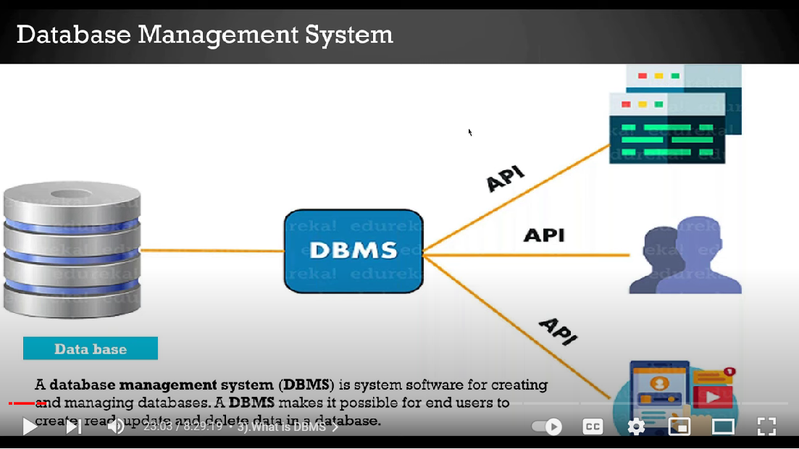

In Data Bases the Data should be saved in the form of tables. This is called as Relational Data Base Management Systems.

